Write Up

A company hired us (Tyler and Nate) to make an elevator for them. Over the past week, and with multiple tests and reconfigurations, have come up with our favorite design that fulfils all the design constraints. The first element that our design has is, our elevator goes to any floor desired, from any floor. This is made possible by the way our code works. Our code is a closed loop program, so this means that the code is always continuously looping so the program doesn’t stall. So, if you were to press the button that puts the elevator at level three, when the elevator is at level 1, it will do it.

The second element is our elevator will return to the ground floor after 10 seconds. This is made possible because of a while loop. While the elevator is not moving, a timer counts up. If the Timer reaches 10 then the elevator returns.

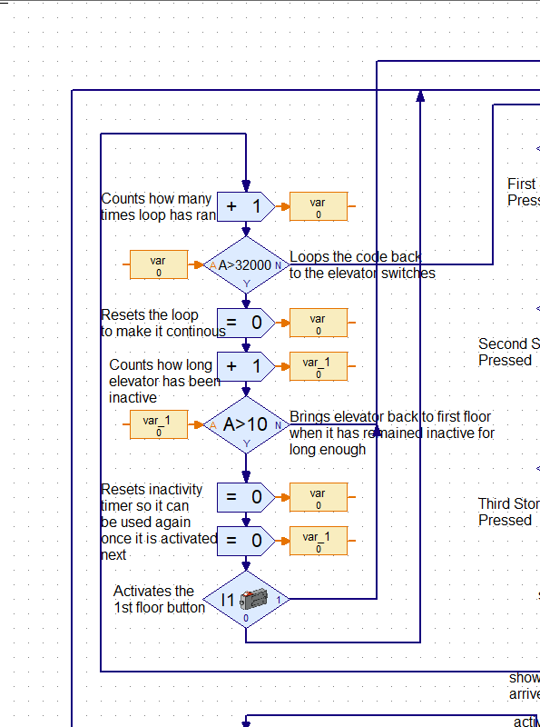

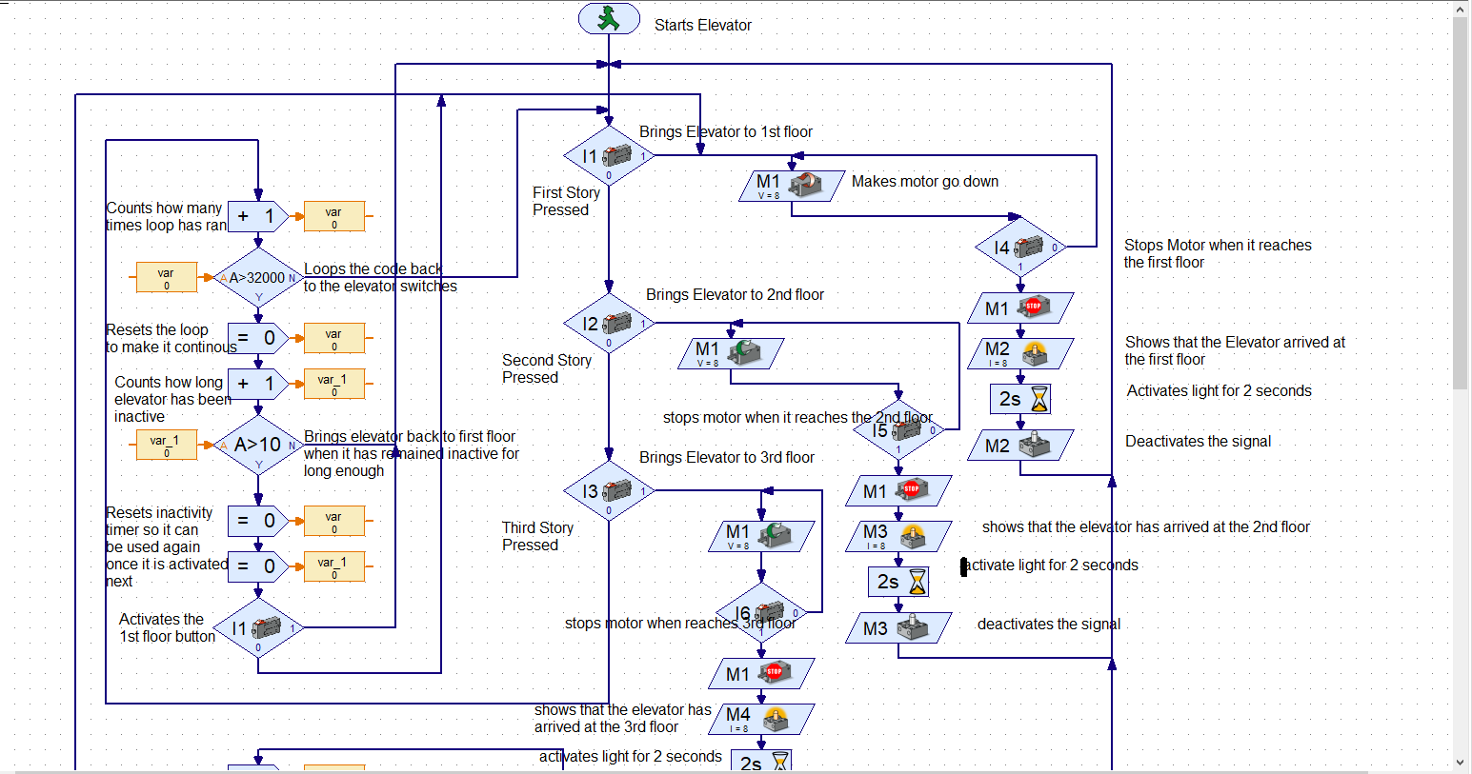

As mentioned earlier, this program is a closed loop program meaning it will loop forever since there is no end.